Claim Registration screens documentation

1) Accident screen

2) Claims Screen – when OD Selected

3) Claims Screen – When PD / BI Selected

4) Service provider screen – when insurer selected

1) Accident Screen

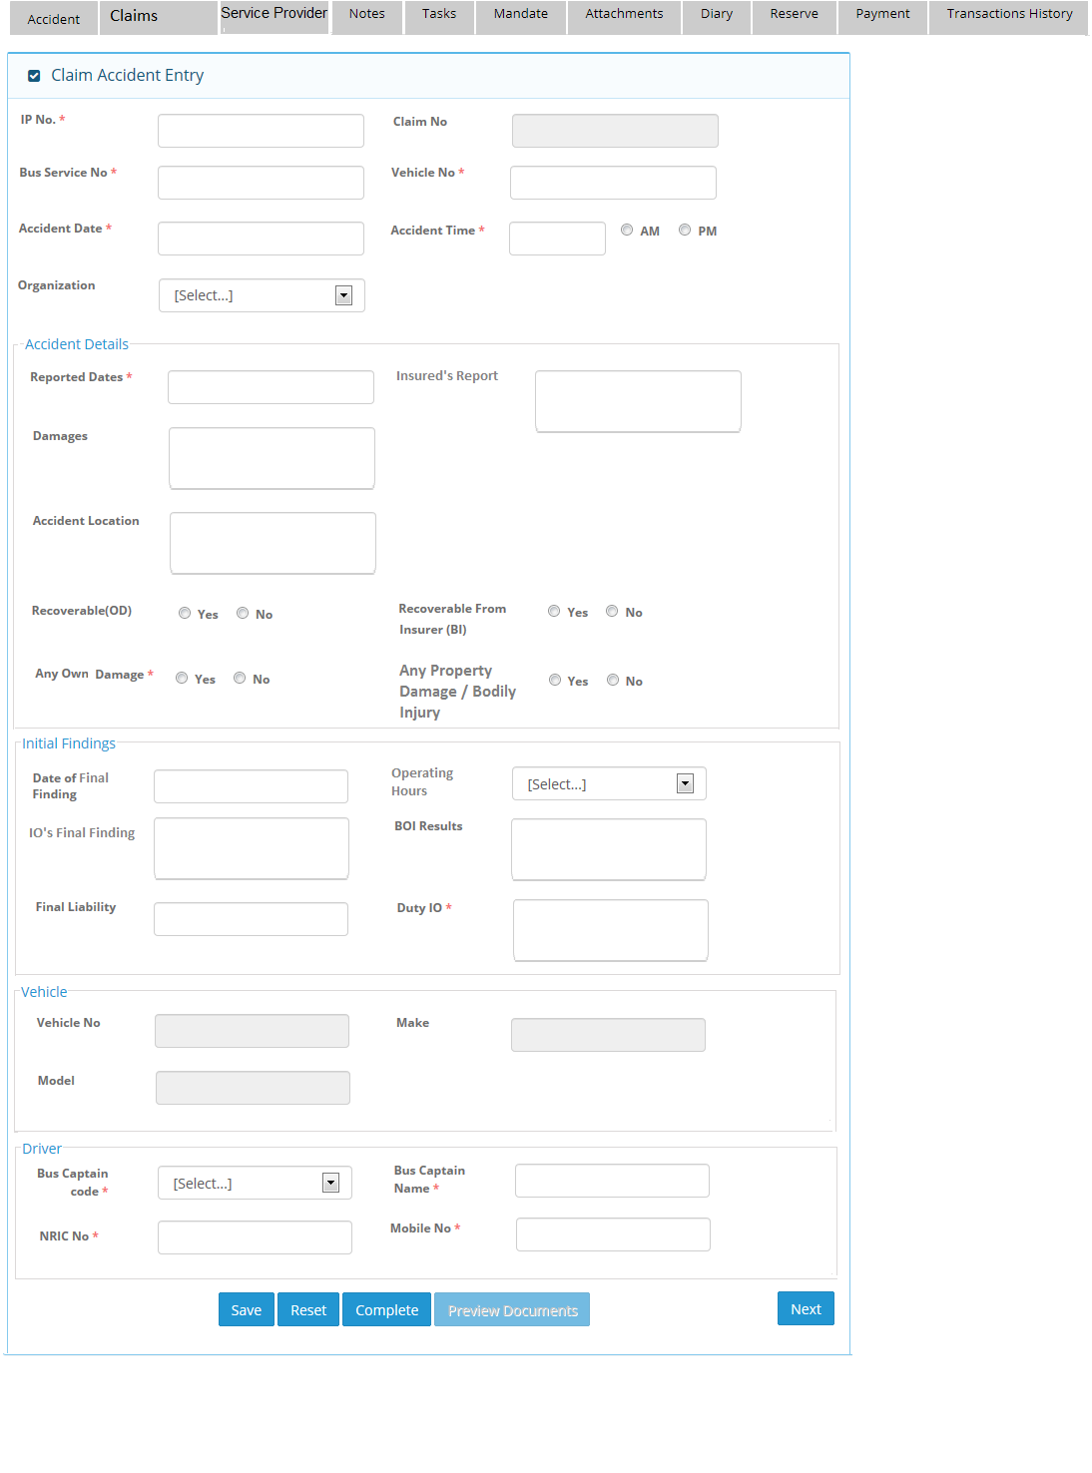

2)Claims Screen when Own Damage selected.

[Varun comments]
I) Can we change “Other Parties” grid header to “Parties” only?
II) Can we change, first section caption name from “3rd party claimant ” to “Claimant Information”.

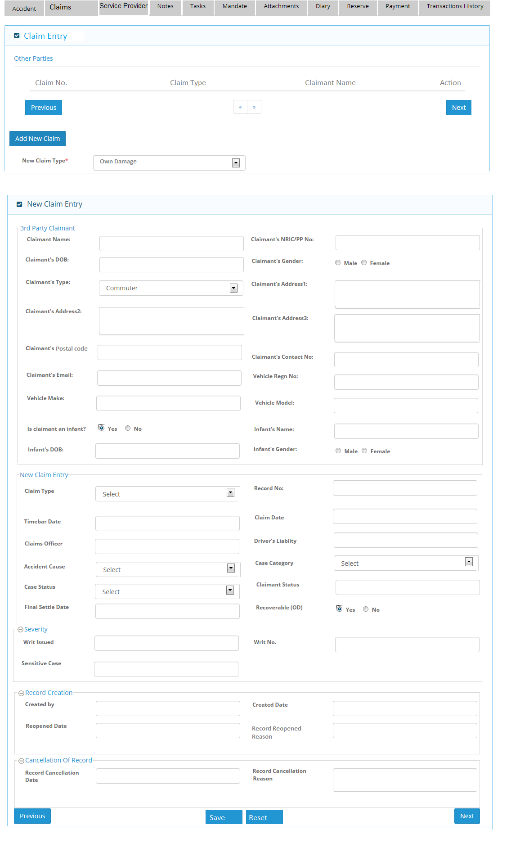

3) Claims Screen – When PD / BI Selected

Note: For Bodily injury, user will choose new claim type as “ Bodily injury” and same screen will come for this
option.
[Varun comments]
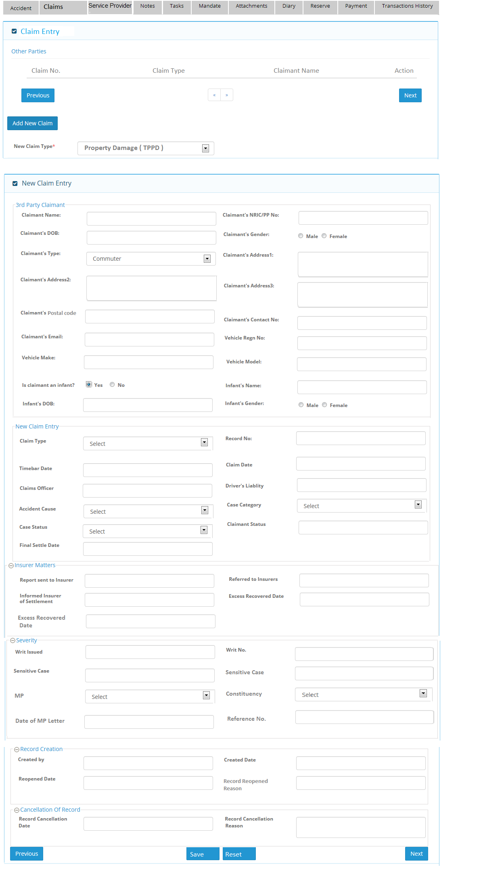
I) Can we change “Other Parties” grid header to “Parties” only.
II) Can we change, first section caption name from “3rd party claimant” to “Claimant Information”.

4) Service provider screen – when Insurer selected
